Course Code: AIPP
Assignment No:11
Done by: 2503B05203 (M.Tech)
Name: B Subhash Chandra
SCHOOL OF COMPUTER SCIENCE AND ARTIFICIAL INTELLIGENCE |  |  |  |  | DEPARTMENTOF COMPUTER SCIENCE ENGINEERING
ProgramName:M. Tech/MCA/MSC |  |  |  | AssignmentType: Lab |  |  | AcademicYear:2025-2026
CourseCoordinatorName |  |  |  | Venkataramana Veeramsetty
CourseCode |  |  |  | CourseTitle |  | AI Assisted Problem Solving Using Python
Year/Sem |  |  | II/I | Regulation |  | R24
DateandDay  of Assignment |  |  | Week5- Monday | Time(s)
Duration |  |  | 2 Hours | Applicableto  Batches
AssignmentNumber:11.3(Presentassignmentnumber)/24(Totalnumberofassignments)
 | Q.No. | Question |  |  |  |  |  | ExpectedTime  to complete
 | 1 | Lab 11 – Data Structures with AI: Implementing Fundamental Structures  Lab Objectives  - To implement fundamental data structures with the assistance of AI tools.  - To understand how AI suggests different implementations and optimizations.  - To analyze the readability, correctness, and performance of AI-generated code.  - To reinforce problem-solving skills using AI-powered coding assistance.  Learning Outcomes  After completing this lab, students will be able to:  - Implement stack, queue, and linked list using Python with AI support.  - Use AI tools to optimize and refactor basic data structure operations.  - Compare multiple AI-suggested implementations for the same structure.  - Apply AI assistance to generate test cases for verifying data structure behavior.  - Demonstrate understanding of trade-offs in AI-generated solutions.  Task Description #1 – Stack class implementation  Task: Ask AI to implement a stack class with push(), pop(), peek() and is_empty() methods  Prompt:  Implement a Stack class in Python with the following methods:  - push(item): Adds an item to the top of the stack.  - pop(): Removes and returns the item from the top of the stack.  - peek(): Returns the item at the top of the stack without removing.  - is_empty(): Checks if the stack is empty and returns True if it is, otherwise False.  Ensure the class is well-structured, easy to use, and includes necessary error handling for cases like popping from an empty stack.  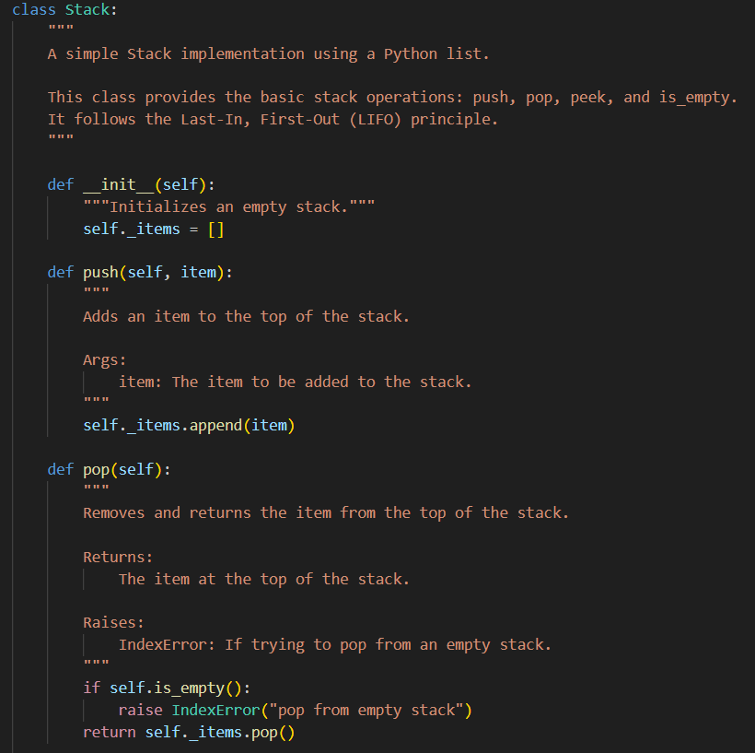  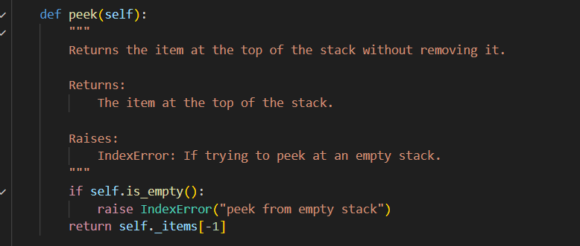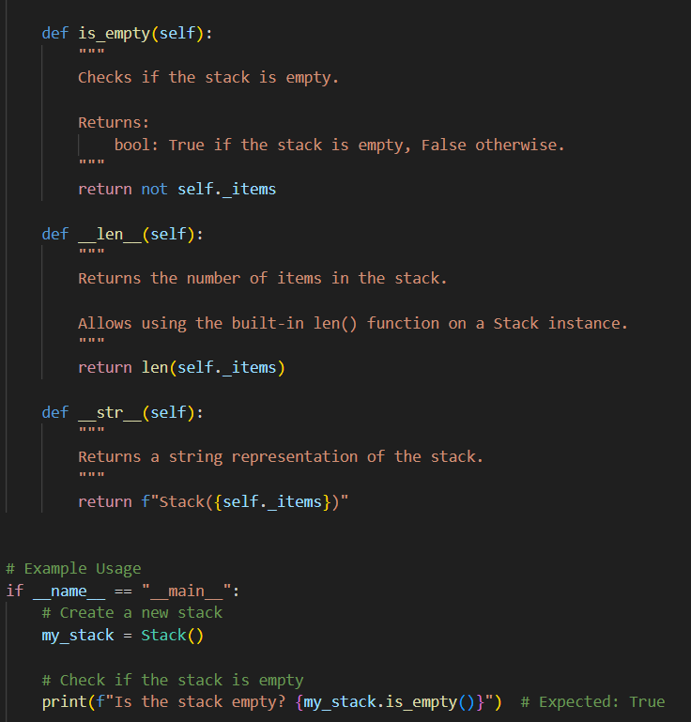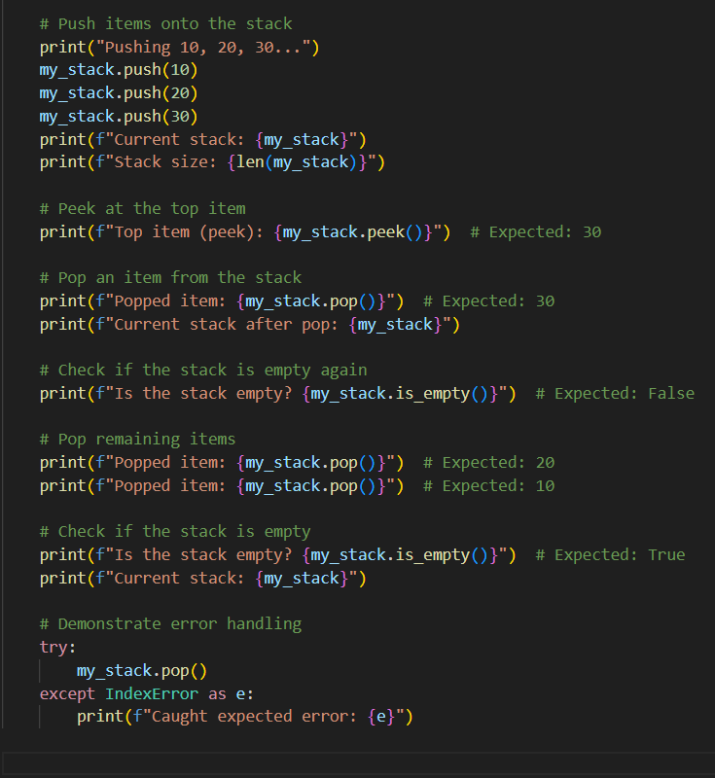  Output:  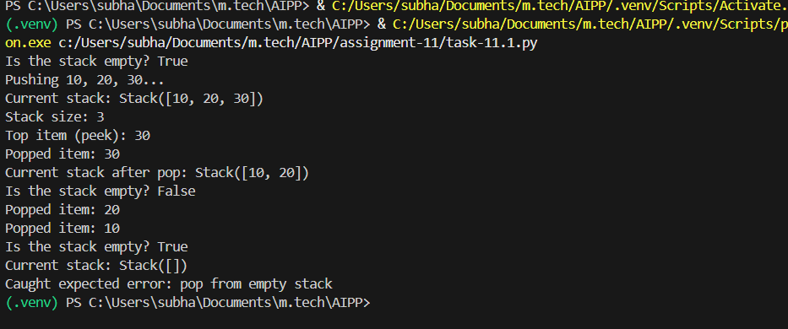  Observation:  - With help of AI we can perform all stack operations (create empty stack and then push some data into stack, then pop the values) successfully.  Task Description #2 – Queue Implementation  Task: Use AI to generate a Queue class with enqueue(), dequeue(), and is_empty().  Prompt:  Implement a queue class in Python with the following methods:  - enqueue(item): Adds an item to the top of the queue.  - dequeue(): Removes and returns the item from the top of the queue.  - is_empty(): Checks if the queue is empty and returns True if it is, otherwise False.  Ensure the class is well-structured, easy to use, and includes necessary error handling for cases like popping from an empty queue.  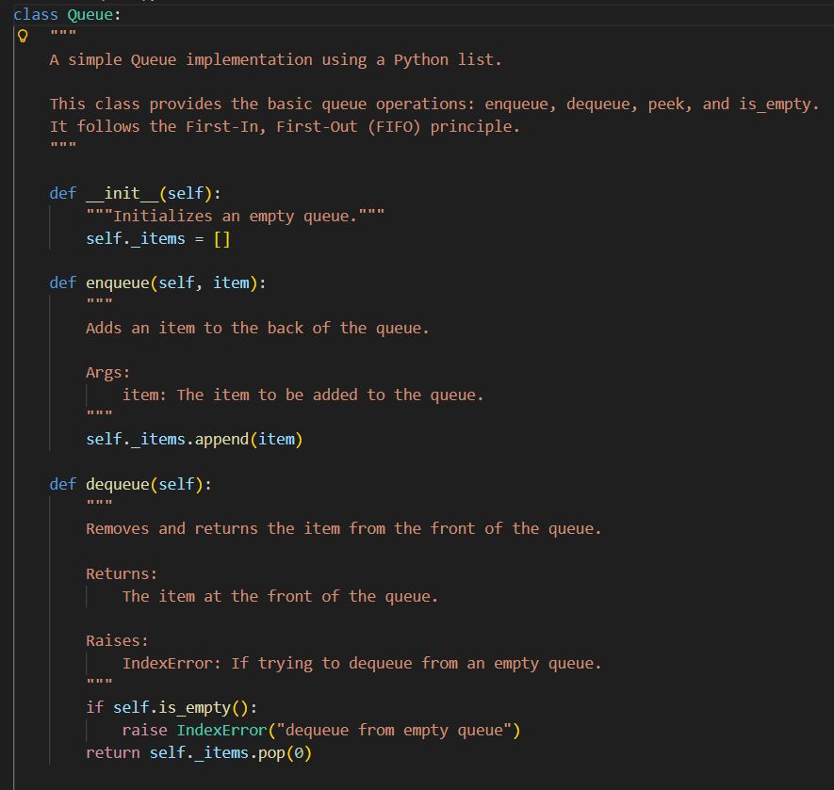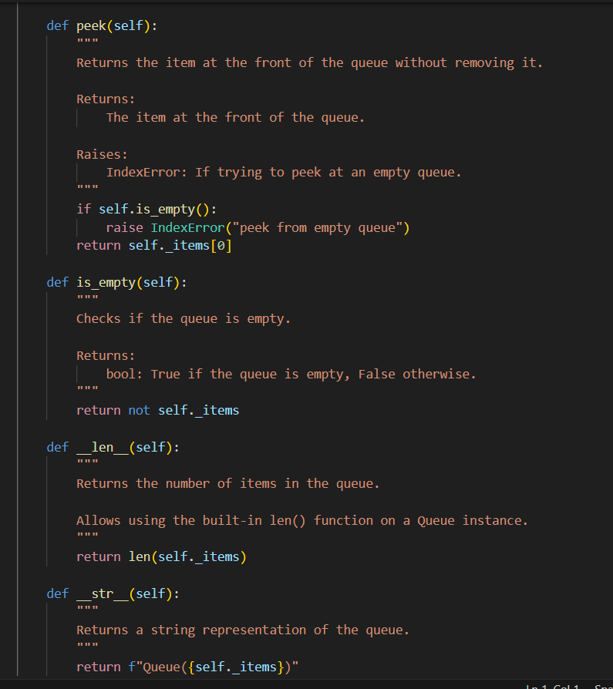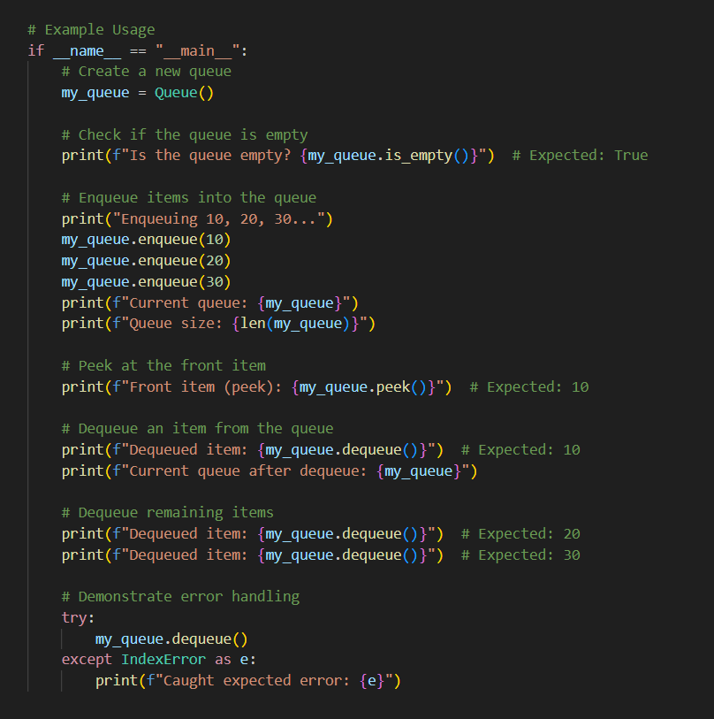  Output:  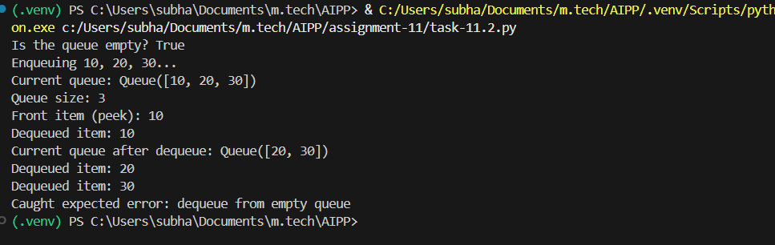  Observation:  - With help of AI we can perform all Queue operations(enqueued, dequeued and checking empty operations) successfully.  Task Description #3 – Linked List Implementation  Task: Ask AI to create a singly linked list with insert_at_end(), insert_at_beginning(), and display().  Prompt:  Create a Python class for a singly linked list with the following methods:  - insert_at_end(data): Inserts a new node with the given data at the end of the list.  - insert_at_beginning(data): Inserts a new node with the given data at the beginning of the list.  - display(): Displays all the elements of the linked list in a readable format.  Ensure the class is well-structured, handles node insertion efficiently, and can display the list contents clearly.  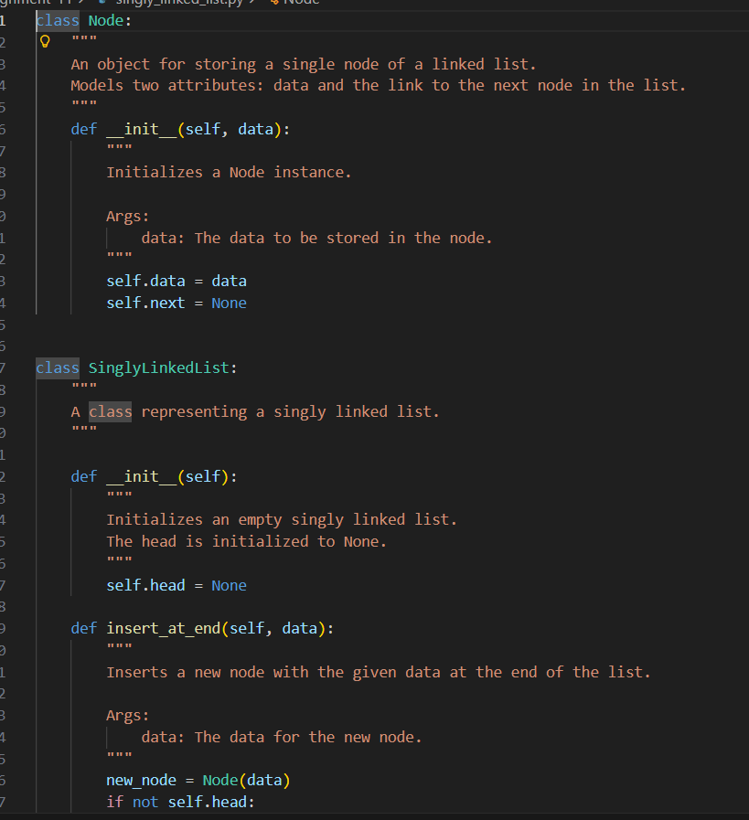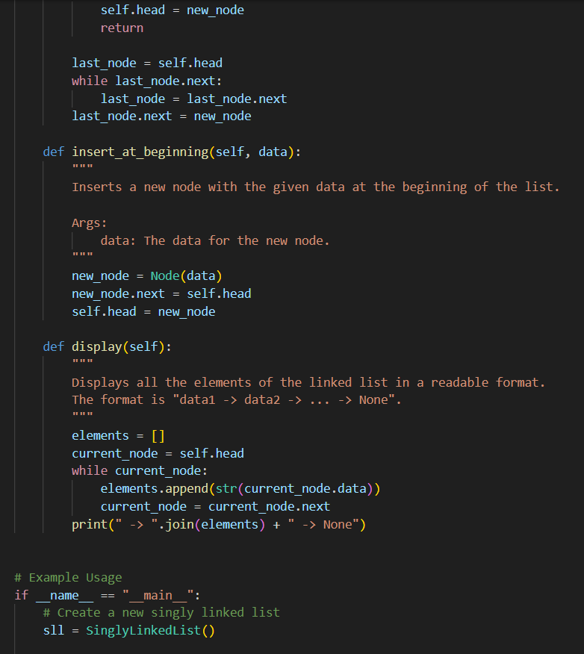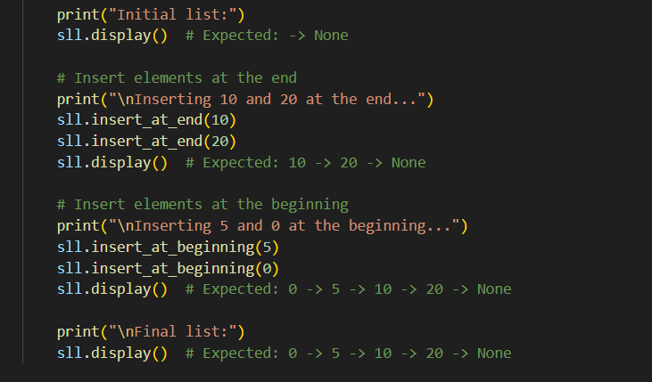  Output:  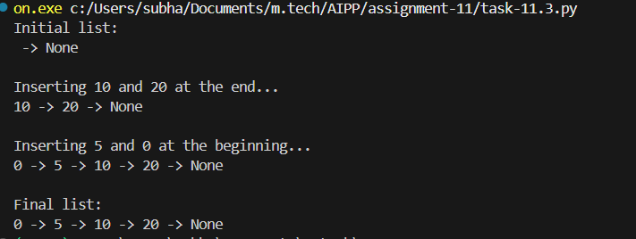  Observation:  - With help of AI we can perform all List operations(inserting at beginning and end , display operations) successfully.  Task Description #4 – Binary Search Tree (BST)  Task: Ask AI to generate a simple BST with insert() and inorder_traversal().  Prompt:  Create a simple Binary Search Tree (BST) class in Python with the following methods:  - insert(data): Inserts a new node with the given data into the correct position in the BST.  - inorder_traversal(): Performs an in-order traversal of the BST and returns the values in sorted order.  Ensure the BST is properly structured and supports efficient insertion and traversal.  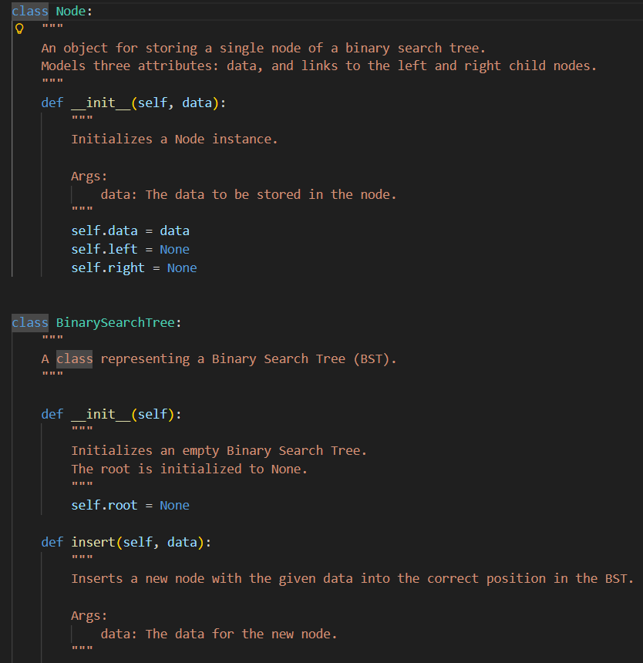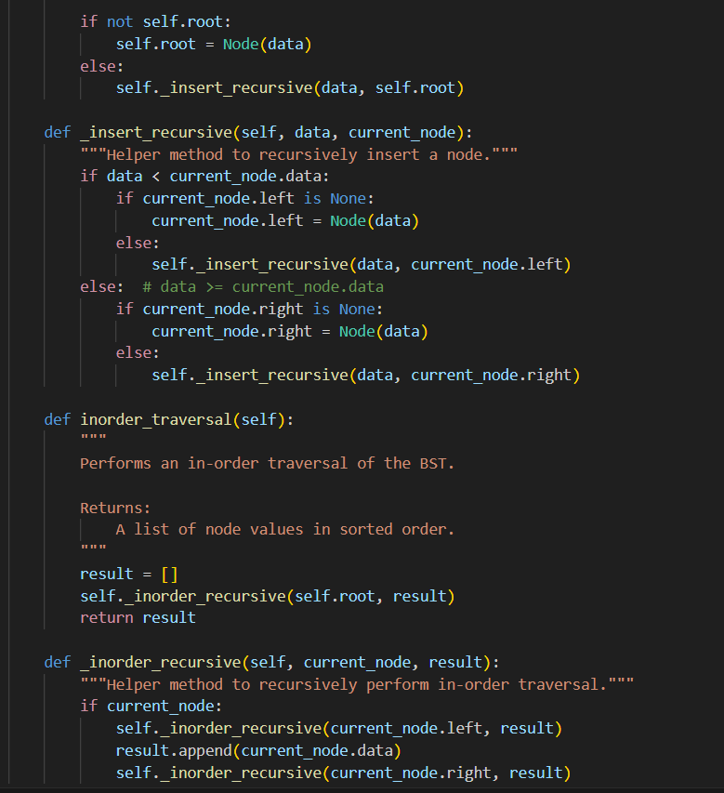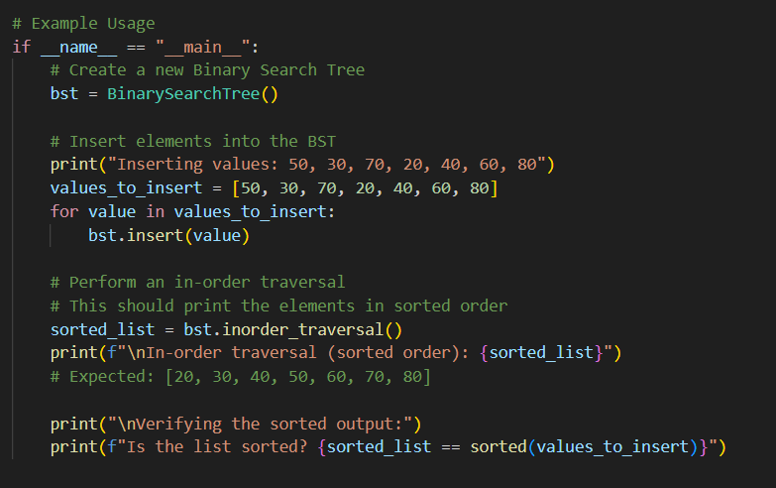  Output:  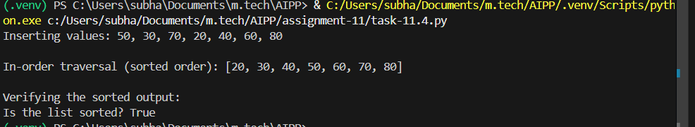  Observation:  - With help of AI we can perform all Binary search tree operations(with insert and inorder_traversal) successfully.  Final Conclusion:  - With the help of AI assisted coding we can do Data Structures and fundamental DSA successfully |  |  |  |  |  | Week5 - Monday

